Python Activity-Based Learning

Vemula siri chandhna
CSM-3:26001049
PROGRAM 1 : Nested List Examination Seating Validation

1. Problem Statement
Develop a Python program to validate an examination seating arrangement represented using a nested list (two-dimensional matrix). The program must identify duplicate student roll numbers, check reserved seating positions, detect empty seats, and identify invalid student allocations.
The program should use Python concepts such as computational thinking, algorithms, flowcharts, pseudocode, variables, data types, operators, conditional statements, loops, strings, pattern generation, lists, nested lists, tuples, tuple operations, and unpacking to validate the seating matrix and generate a clear validation report.
2. Objectives
- Represent the examination seating arrangement using a nested list.
- Identify duplicate roll numbers in the seating matrix.
- Validate reserved seats using tuples containing row and column positions.
- Detect empty seats in the examination hall.
- Identify roll numbers that do not belong to the registered student list.
- Use loops and conditional statements to validate every seat.
- Generate a formatted seating layout and validation report.
- Apply Python lists, tuples, strings, operators, and tuple unpacking to solve a real-world problem.
3. Assumptions
The following assumptions are used in this case study:
Item | Assumption
Seating arrangement | Represented using a nested list
Roll numbers | Stored as strings, such as "101"
Registered students | Stored in a tuple
Reserved seats | Identified using row-column tuples
Empty seats | Represented by "EMPTY"
Reserved seat marker | Represented by "R"
Row and column numbering | Starts from 0 in the program
Duplicate roll numbers | Not allowed
Invalid allocations | Roll numbers not in the registered student list
Complete seating | Every non-reserved seat must have a valid student
Validation result | Report all detected errors instead of stopping at the first error
For example, (0, 2) means the seat in the first row and third column is reserved.
4. Computational Thinking
Computational thinking means solving a problem by dividing it into smaller, manageable steps.
For this case study:
- Decomposition: Divide the problem into checking duplicates, reserved seats, empty seats, and invalid roll numbers.
- Pattern recognition: Identify repeated roll numbers and common seating errors.
- Abstraction: Focus on roll numbers, seat positions, and reservation rules.
- Algorithmic thinking: Follow a sequence of steps to inspect each seat and generate the final report.
5. Algorithm
- Start the program.
- Create a nested list representing the seating matrix.
- Create a tuple containing all registered student roll numbers.
- Create a tuple of reserved seat positions.
- Display the seating matrix with row and column labels.
- Initialize an empty list to store validation errors and another list to track assigned roll numbers.
- Traverse each row and each seat using nested loops.
- Check whether the seat is reserved:
  - If it is reserved, verify that it contains "R".
  - If it is not reserved, check that it does not contain "R".
- Check whether a non-reserved seat is empty.
- Check whether each assigned roll number belongs to the registered student list.
- Check whether a roll number has already appeared.
- Add every detected error to the validation report.
- Display all errors or print a success message if the seating matrix is valid.
- Stop the program.
6. Flowchart
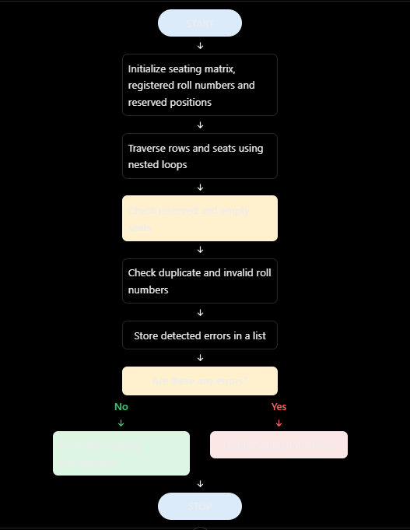

7:PESUDO CODE
BEGIN

SET seating_matrix
SET registered_roll_numbers
SET reserved_positions

CREATE empty error_list
CREATE empty assigned_roll_numbers

DISPLAY seating layout

FOR each row_index and row in seating_matrix
FOR each column_index and seat in row

CREATE position tuple (row_index, column_index)

IF position is reserved
IF seat is not "R"
ADD reserved-seat error
END IF
ELSE
IF seat is "R"
ADD invalid-reservation error
ELSE IF seat is "EMPTY"
ADD empty-seat error
ELSE
IF seat is not in registered_roll_numbers
ADD invalid-roll-number error
END IF

IF seat is already assigned
ADD duplicate-roll-number error
END IF

ADD seat to assigned_roll_numbers
END IF
END IF

END FOR
END FOR

IF error_list is empty
DISPLAY "Seating arrangement is valid"
ELSE
DISPLAY all validation errors
END IF

END

8:PYTHON SOURCE CODE

# Case Study 61: Nested List Examination Seating Validation

# Registered student roll numbers
registered_students = ("101", "102", "103", "104", "105")

# Reserved seat positions (row, column)
reserved_positions = ((0, 2),)

# Nested list representing the seating matrix
seating_matrix = [
["101", "102", "103"],
["103", "EMPTY", "999"]
]

# Lists to store assigned roll numbers and errors
assigned_roll_numbers = []
errors = []

rows = len(seating_matrix)
columns = len(seating_matrix[0])

print("===== EXAMINATION SEATING VALIDATION =====")

# Generate the seating layout pattern
print("\nSeating Arrangement:")
print(" " + " ".join(
"C" + str(c + 1) for c in range(columns)
))

for r, row in enumerate(seating_matrix):
print("Row", r + 1, ":", end=" ")
for seat in row:
print(f"{seat:>5}", end=" ")
print()

# Validate every seat
for row_index, row in enumerate(seating_matrix):
for column_index, seat in enumerate(row):

# Tuple unpacking and tuple creation
position = (row_index, column_index)
is_reserved = position in reserved_positions

# Check reserved positions
if is_reserved and seat != "R":
errors.append(
f"Reserved seat {position} is not marked R."
)

elif not is_reserved and seat == "R":
errors.append(
f"Seat {position} is marked reserved incorrectly."
)

# Check empty seats
if seat == "EMPTY":
if not is_reserved:
errors.append(
f"Empty seat found at {position}."
)

# Check student roll numbers
elif seat != "R":
if seat not in registered_students:
errors.append(
f"Invalid roll number {seat} at {position}."
)

if seat in assigned_roll_numbers:
errors.append(
f"Duplicate roll number {seat} at {position}."
)
else:
assigned_roll_numbers.append(seat)

# Display validation report
print("\n===== VALIDATION REPORT =====")

if len(errors) == 0:
print("Seating arrangement is VALID.")
print("No errors found.")
else:
print("Seating arrangement is INVALID.")
print("Total errors:", len(errors))

for number, error in enumerate(errors, start=1):
print(str(number) + ".", error)

print("\n===== VALIDATION COMPLETED =====")

9. Test Cases
The following test cases verify the program under different conditions.
Test | Seating condition | Expected result
1 | All roll numbers are valid and unique; reserved seats are marked correctly; no empty seats | Valid arrangement
2 | Same roll number appears in two seats | Duplicate error
3 | Student is placed in a reserved position | Reserved-seat error
4 | A non-reserved seat contains "EMPTY" | Empty-seat error
5 | A roll number is not in the registered student tuple | Invalid allocation error
6 | A non-reserved seat is incorrectly marked "R" | Invalid reservation error

10 :OUTPUT
==== EXAMINATION SEATING VALIDATION =====
Seating Arrangement:
C1 C2 C3
Row 1 : 101 102 103
Row 2 : 103 EMPTY 99
VALIDATION REPORT
Seating arrangement is INVAld
Total errors: 4
1. Reserved seat (0, 2) is not marked R.
2. Duplicate roll number 103 at (1, 0).
3. Empty seat found at (1, 1).
4. Invalid roll number 999 at (1, 2).
11. Conclusion
The Nested List Examination Seating Validation program checks an examination seating matrix using Python. It identifies duplicate roll numbers, incorrectly allocated reserved seats, empty seats, and invalid student roll numbers. It uses nested lists, tuples, loops, conditional statements, strings, operators, and tuple unpacking to perform the validation.

